Design Thinking: A UX design framework

**framework** is a conceptual tool that provides guidance on the best practices and processes for solving problems and building solutions that solve the problems of real users.

Frameworks provide structure for the design process and foster collaboration, which can spark innovations. Most UX designers follow a specific framework or process when approaching their work, from the first idea all the way through to the final launch of a product.

In this certificate program, you’ll follow the **Design Thinking** framework to sequence the assignments that contribute to the designs that you’ll create throughout the program.

The **Design Thinking** framework is a user-centered approach to problem-solving that includes activities like research, prototyping, and testing to help you understand who your user is, what their problems are, and what your design should include.

The Design Thinking framework involves the following phases:

1. empathize,
2. define,
3. ideate,
4. prototype, and
5. test.

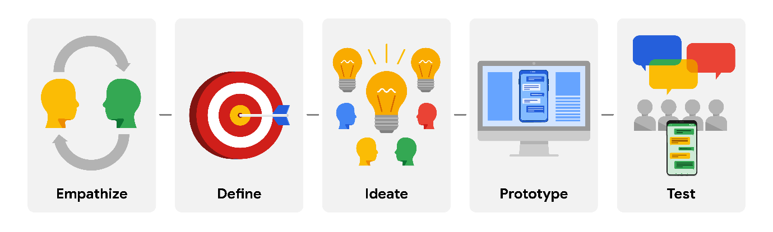

**Empathize**

During the **empathize** phase, your **primary goal** is to learn more about the user and their problems, wants, and needs, and the environment or context in which they’ll experience your design. The most important part of the empathize phase is to step away from your assumptions and guesses and let your research findings inform your decision-making in later design phases.

**Define**

**Define** phase, you’ll analyse your research findings from the empathize phase and determine which user problems are the most important ones to solve, and why. This will drive you toward a clear goal for the design of the product.

**Ideate**

The **goal of ideation** is to come up with as many design solutions as possible—don’t settle for your first solution because the most obvious solution is not always the right one.

* Ideation involves collaborative brainstorming with other members of your team to generate as many solutions as possible to a problem.
* This could include marketing, engineering, product management, or any other stakeholders for the product or service.
* Don’t focus on whether something is a “good” or “bad” idea, just collect as many ideas as you can.
* The important thing here is to keep this process judgment-free.

**Prototype and Test**

After you have an idea of how to solve the problem, you’re ready to enter the **prototype** phase, where your goal is to produce an early model of a product that demonstrates its functionality and can be used for testing. The **test** phase is critical to developing the right solution to address your user’s problem, and an organized approach to testing can help you create exceptional user experiences.

Prototyping and testing are  interconnected, which means that you’ll  test your designs at each stage of prototype development rather than waiting to test until after the working prototype is complete. If the design is too polished the first time you present it to users, you might not get as much feedback. Think about ways to include testing throughout the design process, so that you’re iterating your designs based on user feedback instead of other reasons.

For example, you might test the concepts behind your design by presenting users with a simple sketch, wireframe, or a sitemap. Taking what you learned, you might iterate on that design to a more detailed design on paper (known as a low-fidelity prototype) and conduct another round of user testing. At some point, you’ll iterate the design again into a working, interactive model using a software program (also known as a high-fidelity prototype) and test that as well. You might also consider testing more than one prototype at the same time to get feedback on multiple solutions, or testing the same prototype on multiple platforms, such as a laptop, tablet, and smartphone.

The goal of testing prototypes is to  continue to refine the prototype as you gain insight into whether the design for your product or service is easy to use and solves the user’s problem. At some point, you’ll finalize a prototype, and then you’ll provide it to developers, who will then turn your design into a product.

**Key takeaways**

The Design Thinking framework is only one type of framework that UX designers use to organize their approach to designs, often based on the product they’re designing and the organization they’re working for. No matter which frameworks you use in your career, they all have a few core principles in common:

* Focus on the user.
* Create solutions that address the user’s problems.
* Collaborate with teammates across departments.
* Validate your designs.
* Iterate as needed to design the right user experience.

Throughout the rest of the certificate program, you’ll learn more about each of the phases of the Design Thinking framework and complete practice activities to gain more experience with designing user experiences end-to-end.